Integrating ecology and infrastructure in Hoge Kempen National Park

Research through design on the ecological and recreational defragmentation of the Hoge Kempen National Park, Limburg, and the integration of the highway E314 and the future Spartacus lightrail trajectory in the landscape.

Context
The Hoge Kempen National Park is a unique nature area covering 5700 ha of woodlands and heathlands on a poor sand- and gravel soil. It is a unique cultural landscape that unveils the remains of the transformation from a rural to an industrial society. Apart from its particular natural circumstances, several relicts can be found of the era of coal mining, such as slag heaps, shaft towers and garden cities. The location of the park is on the transition zone of the Kempens Plateau to the Maasvallei (valley of the river Meuse). This transition zone results in interesting gradients with exceptional ecological qualities. Currently, there is an on-going process to recognize the Hoge Kempen National Park as Unesco World Heritage.
The National Park has been opened in 2006, and was one of the initiatives to create new dynamics in the area by refocusing the economic development towards the tourism sector after the closure of the mines. It has been established by a close co-operation between several actors and authorities, and it is the only officially acknowledged National Park in Belgium.
A number of large quarries, from which high quality silica sand and gravel have been extracted, are located in the centre of the National Park. In the east-west direction the E314 highway segments the National Park. In the near future a light rail is planned parallel to the highway. This development will increase the fragmentation of the area.
This project consists a research through design to the ecological and recreational defragmentation of the Hoge Kempen National Park nearby the quarries and the spatial integration of the highway E314 and the planned lightrail-track. Several strategies have been examined to optimise the spatial and ecological coherence in the National Park. An important precondition within this research through design was to search for a strategy in which the revenues of the mining activities could be used to realise the defragmentation.

Problems
As a result of the research through design process, several spatial, ecological and recreational problems and potentials have been revealed. The fragmentation has substantial negative consequences on ecology. The highway forms a barrier between the north and south part of the National Park, which is almost impassable for flora and fauna. Only via the Kikbeek wildlife crossing at the east part of the area it is possible to cross the highway. The realisation of the light rail, parallel to the highway, will increase the effect of the ecological barrier. The quarries form an ecological barrier in the east-west direction. Because of their steep banks, the quarries are not accessible to most species and have therefore almost no ecological value.
Because of the current sand and gravel extraction the groundwater level in Quarry Berg is artificially low. When in 2040 the mining activities cease, the groundwater level will return to its natural height. The current lake banks are not engineered to cope with this water level rise
The bank of the northern quarry is very steep and is located nearby the E314 highway. The future light rail is projected in between this bank and the highway. This poses the danger of decreased stability of the bank, causing the subsidence of the light rail and highway.
Apart from being a physical barrier, the highway causes a visual disruption of the area. Since the area is relatively open and the position of the highway is elevated in comparison to its surroundings, the largest part of the highway are visible from the surrounding area. This is detrimental for the recreational experience of the National Park. Furthermore, the traffic on the highway is also the central source of noise disturbance within the National Park.
The recreational network in the National Park is well developed, in particular at the eastern part. At the western part, a link to the continuous cycling network is missing. The possibilities to cross the highway for both pedestrians and cyclists are limited.

Vision
The goal of the research through design is to reduce fragmentation of the Hoge Kempen National Park for the purpose of ecology and recreation, in a way that resolves the identified problems in the area in an integral way, and that creates a spatially coherent natural park. The barrier effects of the highway and quarries form the biggest constraints.
By adapting the type profile of the highway, all the determined problems can be solved. Narrowing and lowering the highway into the surrounding landscape decreases the noise disturbance and the visual impact. At the same time these interventions facilitate a wild life crossing at ground level. Because of the lower and more stable position of the highway in relation to the nearby quarry, the steep bank of the quarry can be excavated, further increasing stability. The bank becomes wide enough to make a qualitative ecological corridor between the quarry and the highway, which forms the missing link in the ecological passage in east-west direction between the Kikbeek wildlife crossing and the new wildlife crossing. During the works to realise the new highway profile, the opportunity arises to connect the recreational networks on both sides of the highway with each other. The valuable gravel and silica sand that is excavated during the works can be sold to reduce the investment costs.
The groundwater table in the quarry will rise after the extractions have finished. This higher water table has a positive influence on the seepage intensity in the source areas of the nearby steep slope-edges of the Kempens Plateau. In order to stabilize the groundwater table in the quarries, broad dams are installed between the different quarries. These dams also function as east-west oriented ecological corridors between the quarries.

Bottlenecks
Interventions to decrease the effect of barriers or bottlenecks, or to remove barriers altogether, are executed at the locations that form ecological bottlenecks and barriers. A distinction is made between ecological corridors parallel to- and in between the quarries, and the wildlife crossing over the highway.

Groundwater
By creating dams in the northern quarry, the groundwater table can be cascaded into multiple levels, and the discharge can be slowed down. Doing so stabilizes the seepage pressure and optimizes the supply of water towards the streams.

Stability
Excavating the banks of the northern quarry and the E314 creates a stable bank that prevents the subsidence of the highway and creates a solid foundation for the future lightrail.

Sound and vision
Lowering the highway ensures that it is no longer visible from within the National Park. At the same time the walls of the sunken road reduce the level of noise that permeates into the park.

Recreation
The pedestrian and cycling networks will be closed through a bicycle bridge at ground level and a pedestrian tunnel at ground level.

Design
The final design includes the realisation of a broad wild life crossing over the highway at ground level west of the quarries, which is combined with the lowering of the E314 over a length of 1800 metres. Along the lowered highway, sound absorbing walls in combination with berms are implemented, which mitigate traffic noise. The berms are planted with heather and form one spatial entity together with the Kikbeek wildlife crossing and the new wildlife crossing.
The combination of the lowered highway with the narrower profile, and the excavation of the southern bank of the Quarry Berg Zuid, enhances the stability of the bank. The excavation enables an essential wildlife corridor in east-west direction, parallel to the highway. The bank will be excavated to a lower level than the new highway, which creates the possibility of a recreational tunnel for hikers that connects the recreational networks on both sides of the highway.
At the height of the excavation of the bank, the lightrail track is anticipated on the outside of the sound absorbing wall and the berm. By doing so, the profile of the highway can be narrower, increasing the impact of the sound absorbing wall and berm. Moreover, favouring this track allows for a unique way for passengers on the lightrail to experience the Hoge Kempen National Park. Selling sand and gravel excavated during realisation will decrease the net cost of the project.

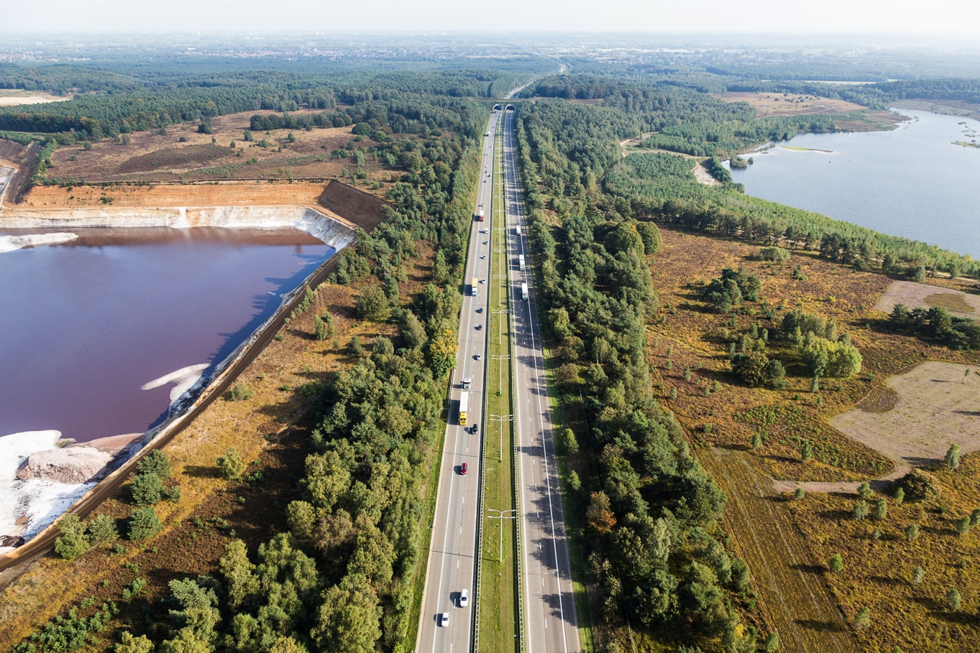
Aerial photograph of the current situation: the E314 highway with Quarry Berg (l) and Quarry Opgrimbie (r)

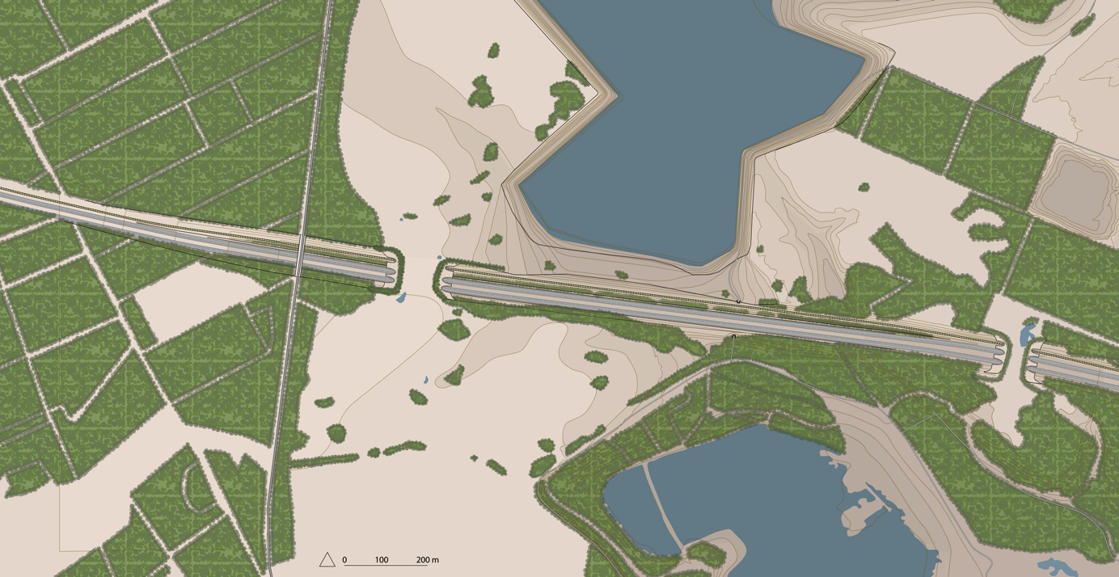
Masterplan

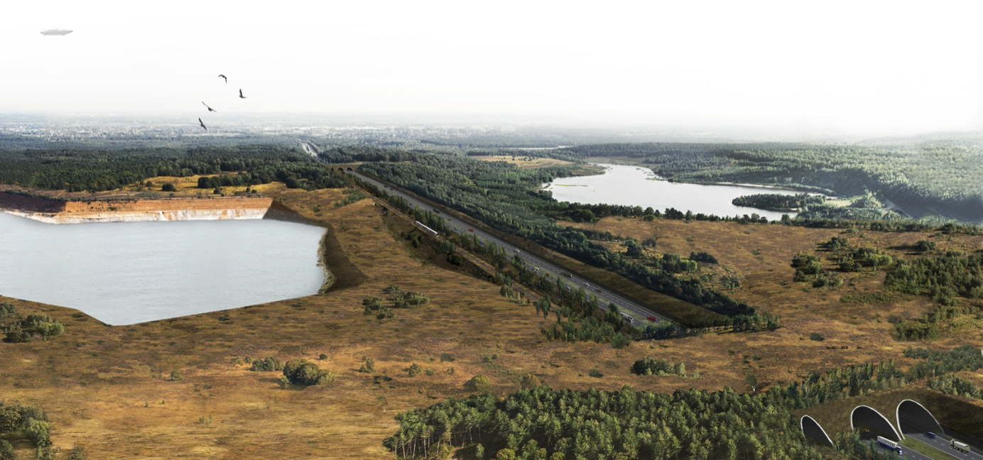
Bird’s eye view of the design

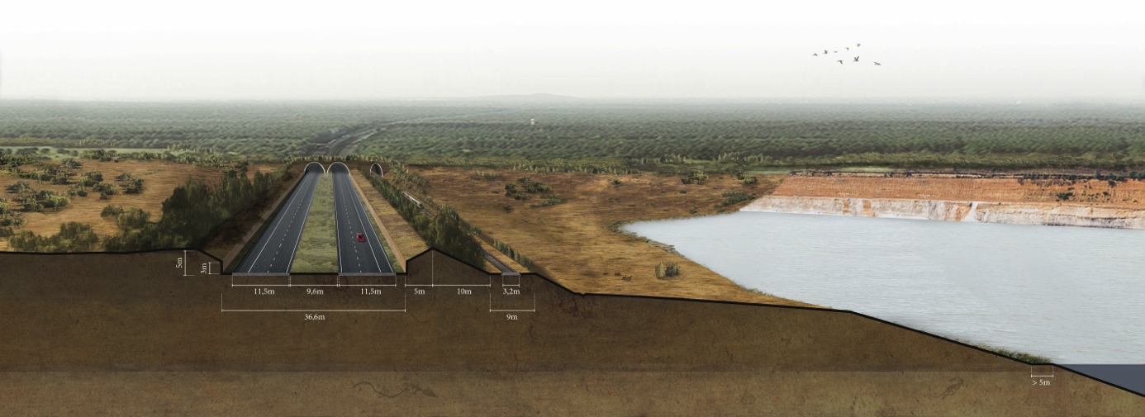
Perspective section of the new profile

